Black Sea Historical Statistics, 1812-1914
Socrates Petmezas and Alexandra Papadopoulou

with the collaboration of George Kostelenos, Gelina Harlaftis, Martin Ivanov, Constantin Ardeleanu, Michael Davidov, Dimitrios Kontogeorgis, Marios Emmanouil, Leonidas Goudelis and Anna Sydorenko

The Black Sea Historical Statistics, 1812-1914 is one of the products of the Black Sea Databases of the Black sea project. The Black Sea Historical Statistics includes primary quantitative information on trade and shipping for each of the port cities of the Black sea region from the early 19th to the early 20th centuries. The novelty of the Black Sea Historical Statistics series is twofold:
A. The Black sea project has been based on extensive research in numerous national Archives and bibliography, both on physical and digital form in more than eight countries (Russia, Ukraine, Georgia, Bulgaria, Romania, Greece, Turkey, Britain, France, and the USA) and provides to researchers the potential to cross-examine and combine data coming from available archival sources concerning trade and shipping for the whole area of the Black sea. This has been possible through the concentration, registration, processing and homogenization of available data across time and space. The great problem in doing research in the Black Sea region is the different languages, scattered archival sources and different weights and measures.
B. Black Sea Historical Statistics, 1812-1914 has been organized around each of the port cities under examination despite political and administrative changes throughout the period. Placing the port city at the center of the analysis makes it easier for researchers to track changes both on a port city level, as well as to compile aggregate data on regions, frontiers and national and empire levels. This approach, running through the whole project, allows the analysis of the long term development of economic space by overcoming the fragmentation of the national archival resources caused by the dense political and economic changes occurring in the wider area during that period.
The aim of the Black Sea Historical Statistics is to provide a corpus of systematic historical statistics that will enable economic historians to integrate the Black Sea area in the global economic history studies.

1. ARCHIVAL SOURCES AND BIBLIOGRAPHY
The Black Sea Historical Statistics has been constructed from data drawn from available archival series of different national and institutional background (official state statistics and consular reports, as well as secondary literature):

I. Russia
The major source of our data stem from the yearly publication of the massive Review of Russian Foreign trade [Obzor vneshnei torgovli Rossii], which was continuously published, from 1812 to 1914. It was more than just an annual Review of Foreign Trade Statistics, including data on navigation and transport, on social groups and structure. In the course of the 19th century, the Obzor changed its title and ministerial denomination, but kept -to a large extent- its structure, while constantly enlarging its volume:
- 1812-1862: Государственная внешняя торговля в разных ее видах [Gosudarstvennaia vneshniaia torgovlia v raznykh ee vidakh] Foreign Trade of the State in its various Regions published by the Department of Foreign Trade of the Ministry of Finances.
- 1863-1869: Виды Государственной Внешней Торговли [Vidy Gosudarstvennoi Vneshnei Torgovli] Review of the Foreign Trade of the State published by the same Department renamed in 1864 as Section of Tariffs and Customs.
- 1870-1917 Обзор внешней торговли России [Obzor vneshnei torgovli Rossii] Review of Russian Foreign trade under the same department.
  - This long series was supplemented by some collections of data such as:
- Vesselovsky, Aleksandr, Tableau du Commerce extérieur de la Russie du 1856 à 1871, St. Petersburg 1873 [published by the Commission Impériale Russe de l’Exposition Universelle de Vienne en 1873].
  - The data was systematically complemented when necessary by the partly bilingual Statistical Yearbook which begun its publication in 1904, changed its title in 1910, and published its final volume in 1916.
- (Статистический) ежегодник Российской Империи (Издания ЦСК) [Annuaire (statistique) de la Russie de la Commité Central de Statistique du Ministère de l’Intérieur]
  - Data of wheat production, transport and trade were also collected and available on-line in the project «Динамика экономического и социального развития России в XIX – начале ХХ вв.» [Dynamics of economic and social development of Russia in the 19th and 20th centuries], directed by professor Leonid I. Borodkin (http://www.hist.msu.ru/Dynamics/index.html)
  - Data of export were amended also by the following publications
- Rubinow, Isaac M., (1908a) Russia's Wheat Trade, Bulletin nº 65 of the Bureau of Statistics of the US Department of Agriculture, Washington.
- Rubinow, Isaac M., (1908b) Russian wheat and wheat flour in European markets, Bulletin nº 66 of the Bureau of Statistics of the US Department of Agriculture, Washington 1908.
- Harvey, Mose Lofley, (1938) The Development of Russian Commerce on the Black Sea and its significance, Unpublished PhD University of California.
  - A considerable amount of original data were collected from the detailed study by prof. Michael Davydov ["Transportation of grain to the ports on the Black Sea and the Sea of Azov in 1893-1913"]. He especially used data "from railway statistics of the Ministry of Finance, statistics on river transport of the Ministry of Communication Lines as well as statistical records of small-scale coastal trade and the Russian customs kept by the Department of Foreign Trade of the Ministry of Finance".
- Davydov, Michael (2016), "Transportation of grain to the ports on the Black Sea and the Sea of Azov in 1893-1913" in Mikhail Davidov, Gelina Harlaftis, Vladimir Kulikov and Vladimir Morozan, The Economic Development of the Port–Cities of the Northern and Southern Black Sea Coast, 19th – Beginning of the 20th century. Transport, Industry and Finance, Black Sea History, volume 4, under publication, www.blacksea.gr, 2016
  - Data on the Russian cereal production were available from 1883 onwards, and they were given for each of the 53 governorates of European Russia. The rich Kuban area, which was devoloped later, was included in 1892, and some of the Asian provinces still later (1893-98). Data were indirectly collected from various contemporary Russian and foreign publications:
- Rubinow, Isaac M., (1906) Russia's Wheat Surplus : Conditions under which it is Produced, Bulletin nº 42 of the Bureau of Statistics of the US Department of Agriculture, Washington.
- Peters, Edward T., (1911) Russian Cereal Crops. Area and production by governments and provinces, Bulletinº 84 of the Bureau of Statistics of the US Department of Agriculture, Washington.
- Obukhov, Vladimir M., ( 1927) Движение урожаев зерновых культур в Европейской России в период 1883-1915 г.г. [Movement crop yields in European Russia in the period 1883-1915] Moscow.

II. Bulgaria
The Bulgarian data were collected for the post-independence period by a group of collaborators under the direction of Dr Martin Ivanov. The group have extensively used the statistical publications of the Bulgarian Statistical Service, which are partly available on-line (see http://statlib.nsi.bg:8181/en/index.php). There is an annual publication of Bulgarian foreign trade and navigation since 1881. The first Statistical Yearbook was published in 1910, but published data on production covered the period since 1901, while data on foreign trade and navigation covered the period from 1881.
- Статистически годишник на Българското царство : 1909 : година първа [Annuaire statistique du Royaume de Bulgarie : 1909 : Première année], Sofia 1910-.
- Статистика за търговията на Българското княжество с чуждите държави през 1882 година [Statistique du commerce de la principauté de Bulgarie avec les pays étrangers pendant l'année 1882], Sofia 1887.
- Data on the Bulgarian economic history had also been provided through

III. Romania
The Statistical Bureau of the Direction of Trade of the Romanian Ministry of Industry and Trade had only intermittently published four volumes of Statistical Yearbooks, before the interwar period (1902, 1909, 1912, 1915-6). The International Danube Commission had also collected data concerning trade and navigation in the Lower Danube, and we have used Ardeleanu (2007), Axenciuc (1992, 2007) and Kontogeorgis (2012) to access them. Cervodeanu and Marinescu (1979) have collected data stemming from British consular archives concerning the pre-1853 grain export trade of the port-cities of Braila and Galatz.
- Annuaire statistique de la Roumanie, Bucharest 1902 (edited by the Statistical Department of the Romanian Finance Ministry)
- Annuaire statistique de la Roumanie, Bucharest 1909.
- Annuaire statistique de la Roumanie, Bucharest 1912.
- Annuaire statistique de la Roumanie 1915-16, Bucharest 1919.
  - Data have been also collected through the following publications:
- Ardeleanu, Constantin (2007) Evoluţia intereselor economice şi politice britanice la gurile Dunării (1829-1914), Braila.
- Axenciuc, Victor (1992) Evoluţia economică a României : cercetări statistico- istorice, 1859-1947, 4 volumes, Bucarest.
- Axenciuc, Victor (2008) La formation et le développement du marché intérieur moderne en Roumanie. Étude et séries statistiques à longue terme (1860-1947), Bucarest.
- Cervodeanu, Paul & Marinescu, Beatrice (1979) “British Trade in the Danubian Ports of Galatz and Braila between 1837 and 1853”, Journal of European Economic History, 8/3, pp.707-742
- Kontogeorgis, Dimitris, (2012) Η ελληνική διασπορά στην Ρουμaνία. Η περίπτωση της ελληνικής παροικίας της Βραΐλας (περ. 1820 – 1914) [Greek Diaspora in Romania. The case of the Greek Community of Braila (c. 1820-1914), Unpublished PhD thesis, University of Athens.

IV. Ottoman Empire
The Ottoman Empire had been able to institute a relatively efficient statistical service in the beginning of the 20th century, a quarter century before the end of the empire and had published a very limited amount of data.
- Güran, Tevfik ed., (1997) Osmanli Devleti’nin ilk Istatistik Yilligi 1897 [The first Ottoman Statistical Yearbook of 1897], Ankara.
Some of these data have been collected and amended by present day economic historians. The bulk of our information stems from French and English Consular archives and from the provincial almanacs (salname) which were of questionable precision. The original data on Ottoman foreign trade have been collected, amended and corrected by Sevket Pamuk (1987, 1995), using the relevant foreign trade statistics of the major importing countries.
Pamuk, Sevket (1987) The Ottoman Empire and European Capitalism, 1820-1913. Trade, Investment and Production, Cambridge.
Pamuk, Sevket ed., (1995) 19 yüzyilda osmanli diš ticareti [The Ottoman Foreign Trade in the 19th century], Ankara.

V. Great Britain
The British Consular Reports of the British Foreign Office (BCR). The British consular reports included data concerning the ports which belonged to the Russian, Ottoman and Romanian dominion. Those ports belong to the northern, eastern, southern and western coast of the Black sea.

In the northern coast of the Black sea the BCR include data for the regions of
Crimea
Evpatoria (1824-1914)
Sevastopol (1883-1914)

The northwestern coast
Odessa (1821-1914)
Nikolayev (1871-1914)

The eastern coast
Novorossyisk (1889-1914)
Batumi (1879-1914)

Azov
Berdyansk (1856-1914)
Mariupol (1857-1914)
Taganrog (1857-1914)
Kertch (1879-1914)

The southern coast
Trabzon (1863-1914)
Samsun (1866-1914)

The western coast
Sulina (after 1878 included in the newly established Romanian state)
Varna (after the 1878 included in the newly established Bulgarian state)
Burgas (after the 1878 included in the newly established Bulgarian state)

VI. France
- The French Statistical Data (FSD) drawn from R. Follin, "Ports et Navigation en Mediterranee. Essai statistique 1870-1905", Navigations Mediterraneennes au XIXe siecle, Vol. 1 (Marseille et les ports Mediterraneens evaluation quantitative), Institut de Recherches Mediterraneennes-Universite de Provence, p. 142-144
- The French statistical data include the following ports:
- Odessa (1870-1905)
- Taganrog (1870-1905)
- Nikolayev (1872-1905)
- Batumi (1879-1905)

VII. Grain Production and world trade
Data on the International wheat trade were basically collected from secondary sources:
- O’Connor, Marion A., (1970) “World Wheat supplies, 1865-1913” [Discussion Paper 12, Woodrow Wilson School, Princeton University], Princeton.
- Rutter, Frank R. (1908) Cereal production of Europe, Bulletin nº 68 of the Bureau of Statistics of the US Department of Agriculture, Washington.

2. UNITS,WEIGHTS AND MEASURES
The final aim of our research was to produce a general purpose database (DB), comprised of the best available data series which were checked for consistency and expressed in comparable units of surface, volume and weight, or monetary units. We have consulted mostly the original Russian, Bulgarian or Romanian statistical publications (see list of Archival Sources and Bibliography), and we were also obliged to extensively use secondary material and data series published in books and working papers of colleagues like Ardeleanu (2007), Cervodeanu (1978, 1979), Davidov (2016), Axenciuc (1992, 2008). Professors Constantin Ardeleanu, Michael Davidov and Dr Martin Ivanov have been also constantly helping us collect materials and improve the DB.

We have expressed all units and values in the standard continental European metric system and in golden francs, the currency unit of the Latin Monetary Union (LMU). Any such choice is by definition arbitrary and depends on convenience and the national bias of the researchers. In our case it also stems from convenience, since the Eastern European countries, whose statistical data were used in this DB, had officially adopted the French metric system and have pegged their monetary system on the LMU golden franc. All values in this DB are expressed in LMU golden francs and all volumes are given in metric tons of 1,000 kg. We have tried to avoid including volumes of dry weight, but when this was unavoidable, the standard hl of 100 liters is used. The ha of 10,000 sq.m is the major surface unit and the km of 1,000 m the unit of distance.
If data from the Eastern European statistical publications in the DB were mostly used directly, data stemming from the equivalent Ottoman and Russian sources were being silently converted in the standard continental European metric system and in LMU golden francs. Missing data are left blank.

Unit conversions
The Ottoman monetary system was, since 1844, officially pegged to the UK£ at a rate of 1.1 Ottoman lira (T£) to the UK£. There were 100 gürüş to each T£, and there was thus an implicit peg to the golden franc at the rate of 4.4 gürüş to the franc. For the period before 1844, we have adopted the Sevket Pamuk deflator. Until November 1881, when Greece effectively appreciated its official golden drachma in par with the LMU franc, the older Greek drachma was the equivalent of 1.12 golden francs. The Romanian lei was also effectively pegged to the golden franc since 1867 and officially since 1889. The Bulgarian leva and the Serbian dinar were also officially pegged to the franc since 1880 and 1878 respectively.
The standard Ottoman measures and weights were fundamentally different from the metric system (see Table 1). The oka of 1.28 kg was the major unit of weight while the kile (composed of 4 sinik) or was the main measure of dry mass. Surface areas were measured in dönüm (officially equal to 918 sq.m. or 0.092 ha).

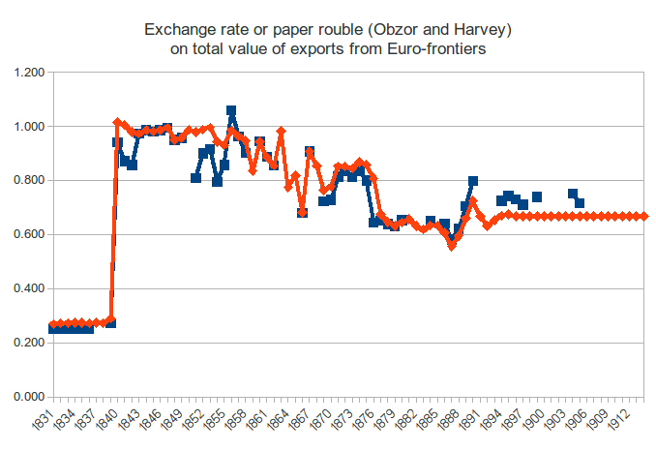

The Russian system was also different in measures and weights (see table 2), but its major variance was the fact that there was no standard golden peg until 1897, when finally the golden standard was officially adopted at a rate of 2.67 francs per golden ruble. Until then, the ruble (called paper or credit ruble) was a paper note whose price was fluctuating (see table 3). In 1885, the golden ruble unit (at the current rate of 10 paper to one gold ruble) was introduced. Thus, since 1885, there was a peg of the golden ruble unit to the golden franc, at a ratio of 4 francs per ruble (thus there was a conversion ratio of 1.5 standard golden rubles of 1897 to the golden ruble unit of 1885). The major problem is to establish a coherent annual deflator for the paper ruble. In this DB we have adopted the paper ruble deflator elaborated by Harvey (1938, Annex A1, p.341).

The Russian system of weights was using a standard weight unit, the pud (пуд), equal to 16.38 kg. All volumes of exports and production after 1885 are usually given in pud. Before this year volumes were customarily given in chetvert (четверть), which was the official dry mass unit. It was equal to 2.10 hl or 5.77 British imperial and 5.96 US bushels. It is worth adding that the extensively used in our documentation British imperial quarter (qr) of the long hundredweight (cwt) weighted 28 lb (each lb corresponding to 453.6 gr) or 12.7 kg.

Grains | kg per chetvert | kg per US bushel | kg per kile | kg per hl
Wheat | 162.13 | 27.22 | 25.64 | 77.23
rye, maize | 151.32 | 25.40 | 23.93 | 72.09
barley, buckwheat | 129.70 | 21.77 | 20.51 | 61.79
oats | 86.47 | 14.52 | 13.67 | 41.19
spelt | 83.76 | 14.06 | 13.25 | 39.90
millet | 123.20 | 22.68 | 21.37 | 58.69

The Russian unit of surface was the desiatina (десятин). The state desiatina measured 1.0925 ha, but there was also a larger landlord desiatina (equal to 1⅓ state desiatina). Distance was measured in verst of 1,066.8 m. The independent Greek, Serbian, Romanian and (the autonomous) Bulgarian states adopted the metric system and pegged their currency to the LMU golden franc, but being initially parts of the Ottoman real they shared with the Ottomans their weight and measures. Surfaces were measured in dekar (декар) in Bulgaria or stremma in Greece. This was officially equal to 1,000 sq.m. or one tenth of a ha.

3. STRUCTURE OF THE BLACK SEA HISTORICAL STATISTICS
There are two kinds of statistics, firstly the Trade statistics and secondly the Shipping statistics.
3.1.TRADE STATISTICS
There is one Excel file with three sheets.
- The first sheet has the trade statistics for 18 port-cities for which we have found trade data
  - For each port city there are 12 columns: 1) total value of exports in French francs (FF) 2) total value of imports in FF, 3) tons of exports of wheat 4) tons of exports of rye 5) tons of exports of barley 6) tons of exports of oats 7) tons of exports of maize 8) value of exports of wheat in FF 9) value of exports of rye in FF 10) value of exports of barley in FF 11) value of exports of oats in FF 12) value of exports of maize in FF
  - Especially for the port-cities of Odessa, Nikolayev, Kherson and Theodosia some additional columns were added: in Odessa 10 more columns covering the entry into the city of the five types of grains (wheat, rye, barley, oats, “all other grains”) either by railway or small maritime transit. For Nikolayev 10 more columns covering the entry into the city of the five types of grains (wheat, rye, barley, oats, “all other grains”) either by railway or by river. For Kherson 10 more columns covering the entry into the city of the five types of grains (wheat, rye, barley, oats, “all other grains”) by railway and the clearance of the same 5 grains by small maritime transport. For Theodosia 5 more columns covering the entry into the city of the five types of grains (wheat, rye, barley, oats, “all other grains”)
  - No data were found for the Ottoman cities
- The second sheet contains national statistics
  - It contains national statistics for Bulgaria, Romania, Russian Empire (Europe and All Russian), Ottoman Empire. More specifically
    - For Bulgaria and Romania there are 18 columns in each that contain: in columns 1-2) the total value of exports and imports (in FF), 3-8) the production of 6 kinds of grain (wheat, maslin, barley, rye, oats, maize) in tons, 9-13) the volume of exports of 5 kinds of grain (wheat, maslin, barley, rye, oats, maize) in tons, and 14-18) the value of the same exports in French Francs. NOTE: no data have been yet included in columns 14-18 for Romania.
    - For the Russian Empire there are 32 columns that contain 1-2) the total exports and imports of European Russia in FF; 3-7) the total production in tons of 5 kinds of grain (wheat, rye, barley, oats, “all other grains”) for the 50 governorates of European Russia; 8-12) the total production in tons of 5 kinds of grain (wheat, rye, barley, oats, “all other grains”) for European Russia; 13-17) the total production in tons of 5 kinds of grain (wheat, rye, barley, oats, “all other grains”) for the whole the Russian empire (excluding Finland) 18-22) the total production in tons of 5 kinds of grain (wheat, rye, barley, oats, “all other grains”) for the whole the Russian empire; 23-27) the volume of exports of 5 kinds of grain (wheat, rye, barley, oats, maize) in tons; 28-32) the volume of exports of 5 kinds of grain (wheat, rye, barley, oats, maize) in FF.
    - For the Ottoman Empire there are 8 columns that contain 1-2) the total exports and imports in FF; 3-4) the total volume of exports of wheat and barley in tons; 5-6) the total value of exports of wheat and barley in FF; 7-8) the average price of wheat and barley in FF per metric quintal.

- The third sheet contains the international trade of the Russian Empire.
  - In more detail they contain
  - a) total Russian exports to Great Britain, Germany, the Netherlands, Belgium, France, Austro-Hungary, Denmark, Ottoman Empire, Spain, Portugal, Sweden, Norway, Romania, Greece, Switzerland, Bulgaria, Serbia, China, Persia, Afghanistan, USA, India, Egypt and other states,
  - b) total Russian imports from Great Britain, Germany, the Netherlands, Belgium, France, Austro-Hungary, Denmark, Ottoman Empire, Spain, Portugal, Sweden Norway, Romania, Greece, Switzerland, Bulgaria, Serbia, China, Persia, Afghanistan, USA, India, Egypt and other states
  - c) the structure of the Russian trade (imports from and exports to) in four major categories (living animals, provisions, raw materials and intermediary products and manufactures). These 8 aggregate categories are given for the whole of the Russian Empire (all frontiers included) and for the subtotal of the custom offices of the Black Sea ports.
  - d) total Romanian exports to and imports from Britain, Austria-Hungary, Belgium, Bulgaria, Egypt, Switzerland, France, Germany, Gibraltar, Greece, Italy, Holland, Portugal, Russia, Serbia, Spain, USA, Sweden, Norway, Ottoman Empire and other countries in FF.
  - e) total Romanian exports in five major categories (living animals, agricultural products, wood and other industries, petroleum, sundry) in FF.
  - f) total Bulgarian exports of major grains (wheat, barley, rye, oats, maize) to major trade partners in FF (UK, France, Belgium, Germany, Austria-Hungary, Greece, Italy, Spain, Ottoman Empire, Holland, Romania, other countries.

The trade statistics, as already explained in part 2 of the present paper, have been homogenized with conversions to tons and French Francs.

3.2. SHIPPING
There are 21 Excel files with four sheets for each of the 21 port-cities for which we have found shipping data:
The northern coast include the following sub-regions:
Crimea which include the following three ports:
Evpatoria (1824-1914)
Sevastopol (1860-1914)
Theodosia (1824-1914)

the region of northern western coast referring to the ports
Odessa (1825-1914)
Nikolayev (1847-1914)

The eastern coast of the Black sea include the following two ports:
Novorossiysk (1852-1914)
Batumi (1878-1914)

and the Azov sea which include the following five ports:
Mariupol (1842-1914)
Rostov on Don (1842-1914)
Taganrog (1824-1914)
Kertch (1824-1914)
Berdyansk (1842-1914)

Each folder of the port cities includes two excel files for the two main economic activities, trade and shipping. Each excel file consists of a number of sheets which is equal to the number of sources from which the data on each port city were extracted. For example, in the case of the port of Odessa, the excel file ODESSA_SHIPPING consists of three excel sheets based on the three archival sources from which the data are drawn under the names, ODESSA_OBZOR, ODESSA_BCR, ODESSA_FCR.
The database of historical statistics on shipping entering or clearing from the twenty one port cities of the Black sea from 1800-1914 includes columns which contain data constructed through various estimations which aim to facilitate its use by historians and statisticians. These estimations aim to overcome the problems caused by the fragmentation of historical archival sources. We have produced a series of fields not included originally in the archival sources referring to the flags of the ships arriving or clearing from the ports of the Black sea using time projections. In particular, we have created three groups of flags of the fleets active in the Black sea ports, namely the German, the Italian and the Scandinavian flag.
The field of the GERMAN TOTAL_EST, GERMAN SAIL_EST and GERMAN STEAM_EST are the aggregates of the number of ships and tonnage under the German flag throughout the period. Up to 1871, when the unification of the German states under the German Empire occurred, the number and tonnage of ships, both sail and steam ships, are estimated by the sum of the fleet under the various flags of the German states referred to the lists of the official statistics, namely Oldenburg, Hannover, Meklenburg, Bremen, Hamburg, Hanseatic cities and Prussia (see map 1).

Map 1.The German Empire, 1871-1918

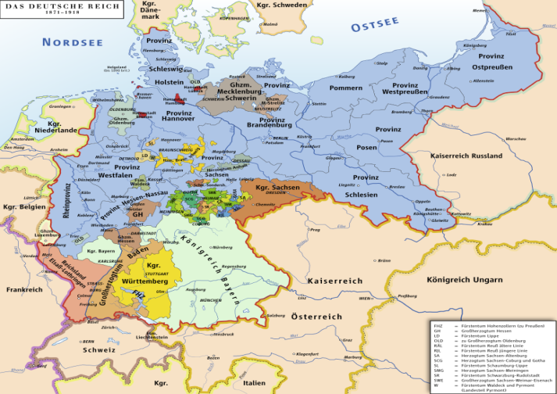

Likewise, the estimations of the total number of ships and tonnage, both sail and steam, under the Italian flag, included in the fields ITALIAN TOTAL_EST, ITALIAN SAIL_EST and ITALIAN STEAM_EST, until the unification of the Italian kingdoms and states in 1871, have been calculated as the sum of the fleets of the various Italian kingdoms and cities, namely Sardinia, Tuscany and Napoli; the latter after 1871 were included after their unification in the Italian Kingdom (see map 2).
Map 2. The Italian Kingdom after 1871.
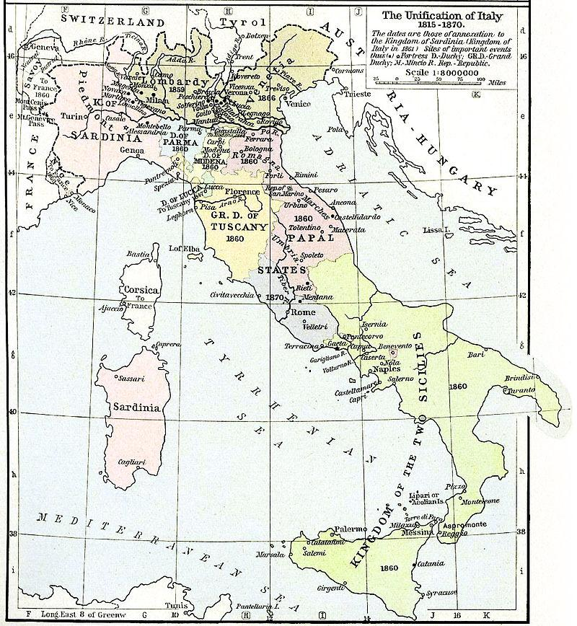

Lastly, the database also includes an estimation of the fleet under the flags of Norway, Sweden and Denmark under the title Scandinavian flag (SCANDINAVIAN TOTAL_EST, SCANDINAVIAN SAIL_EST and SCANDINAVIAN STEAM_EST) though no such flag has been registered in archival sources. This aimed to the homogenization of historical series which from time to time provided a sum of the aforementioned fleets.
Each data sheet also provides a grand total of the number and tonnage of ships entering and clearing for each port city, inscribed under the name GRAND TOTAL_EST, GRAND TOTAL SAIL_EST and GRAND TOTAL STEAM_EST. However, in all cases, the database also provides the data in their initial form, as recorded in the archival sources.

Tonnage measurement standardization
We still have not made the homogenization of shipping statistics and have kept in different files the Russian, the Romanian, the British and the French statistics for each city. We hope that soon we will be able to create our own estimation of the shipping statistics for arrivals and departures based on the archival data we have collected.
The main problem with nineteenth century shipping statistics is the incompatibility between different periods. The difficulty stems from changes in methods of tonnage measurement. Tonnage measurement has a complicated history but it has always being indispensable to estimate a vessel's size and carrying capacity. The method of measurement has also been of great importance since it was used globally to calculate freights, port dues, pilotage, towage and quarantine charges, as well as insurance premiums and taxes. In England and France it was traditional to measure volume in cargo tons, or so-called deadweight tons, according to the wine barrels used in the Bordeaux wine trade called `tonneau'.
Tonnage measurement in the first third of the nineteenth century was based on the so-called Builders Old Measurement (B.O.M.) rule voted by the British Parliament as follows in 1773:
[(coef.)keel length] x breadth x [(coef. depth)]/94
The idea was that if the ship were a parallelogram, the volume would be measured by the product of the length, breadth, and depth and would be expressed in tons of 100 cubic feet by dividing by 100. However, the vessel being rounded towards the keel and sharpened at the ends, its sides are not parallel and consequently it has a volume considerably less than the above product. The rule of B.O.M. was an attempt to estimate the space of the vessel by the product of length, breadth and depth modified by some coefficients and a divisor intended to deduct a fraction of the result obtained to allow for such rounding off.¹ This rule remained valid in Britain, with some modifications in 1836, until 1854. The introduction of steam rendered the old type of measurement obsolete and a new method was needed. When this was developed, the result of the works of a committee presided over by Admiral Moorsom, it set the basis for what we call today gross and net registered tonnage. It set the ton as a unit equal to 100 cubic feet or 2.83 cubic meters. The new method was based on more accurate measurements of the ship by dividing it and calculating various parts of it at a time. Within the next thirty-five years all nations adopted this type of measurement.

The French had adopted the rule of B.O.M. since 1794 to provide their ships with the same rules that prevailed in the larger British fleet. But when the British made some modifications in 1836 it meant that a British ship of 80 tons was equivalent to a French ship of 100 tons. To maintain their competitiveness and not pay higher dues than the British, the French diminished this difference to 3 per cent with a new law in 1838. In the case of Russian ships, the Russian used the metric unit of ships the "last"; 1 last = 200 cubic pud.

Finally, on 12 February 1878, in the Constantinople Conference of 1873 all countries adhered to the Moorsom ton. It set the ton as a unit equal to 100 cubic feet or 2.83 cubic meters. It was in 1879 that the Russian adopted the Moorsom ton as a unit equal to 100 cubic feet or 2.83 cubic meters. However, it was in the calculation of the net registered ton and the gross registered tons the Russians differed. Russians calculated in a way the net registered ton was about 32% less than the gross registered ton, which means that it was bigger than the English net register ton which was about 40% less than the gross register ton. This meant that Russian ships had to pay much larger dues in the ports as they were calculated on the basis of net register tons. The homogenization of the Russian system of calculation of tonnage with the British system took place on 2 March 1900.

Since 1910 as annuaire statistique.
The Preliminary Treaty of San Stefano, later validated at the Congress of Berlin, was a treaty between Russia and the Ottoman Empire signed at San Stefano, then a village west of Constantinople, on 3 March 1878. The treaty ended the Russo-Turkish War, 1877–78 and granted the independence of the Bulgarian and the Romanian state. In exchange for the war reparations, the Porte ceded Armenian and Georgian territories in the Caucasus to Russia, including the port of Batumi.
The treaty granted the independence of the Bulgarian and the Romanian state.
See above.
The LMU, founded in 1865, was initially a bimetallic monetary system with the franc containing 4.5 gr of fine silver, the equivalent of 0.290322 gr of gold (i.e. at a ratio of 1:15.5). In 1873, after the rapid depreciation of silver in the early 1870s, the LMU integrated the gold standard. Italy, Belgium, Switzerland, Spain and Greece were officially member states. Other weaker national monetary systems were tacitly streamlined on the LMU golden franc: Spain, Romania, Bulgaria, Serbia, even Russian Finland were such cases. Of course, coins and banknotes in everyday use were not necessarily at par with the official golden monetary unit. Nevertheless, aggregates and values in the Greek, Bulgarian and Romanian statistical publications were expressed in the official golden currency units. The LMU disbanded with the official devaluation of the golden franc in 1927. The Swiss Franc continued to stand on the golden base of the LMU franc, and it can be used to project the LMU golden franc exchange rare to the end of the Bretton Woods era and the abandonment of gold in October 1976.
It is worth reminding that under the gold standard, the Austro-Hungarian golden korona (1893-) was officially exchanged with the golden franc at a rate of 1.05 francs, the German golden mark (1873-) at 1.22, the US$ at 5.14 and the UK at 25 francs.
209.91 liters
13.See Michael Marshall, Ocean Traders, New York, Facts-on-File, 1990; R. Riegel, Merchant Vessels, 1921, pp. 185-90.
Russki kommercheski flot po 1-e ianvaria 1858 goda, St. Petersburg, 1858; Russki torgovyi flot. Spisok sudov k 1 ianvaria 1903 g., St. Petersburg, 1903.
The Constantinople Conference of 1873 introduced two measurement rules according to the Moorsom system, rule A and rule B. Rule A was the accurate way of measuring the vessel but the problem was that the ship had to be empty for a few days to take the measurements. To give ships provisional measurements until they were re-measured under Rule A, the Conference provided that if it were loaded it could be temporarily measured by Rule B, a method based on the old BOM system which yielded approximate results. A large number of vessels that came to Greek ports were laden and hence were measured by Rule B. The problem with the Greek law was that it did not specify that this was temporary and hence most remained measured under Rule B. As a result there are many small discrepancies between Lloyd's Register of Shipping and the Greek registries. See Gelina Harlaftis, Α Ηistory of Greek-Owned Shipping. The Making of an International Tramp Fleet, 1830 to the present day, London, Routledge, 1996, chapter 4.

